APPENDICES

I. STANDARD OPERATING PROCEDURES and FLOWCHARTS
- 2.2 SOP UAG Participant Recruitment- Enrolment
- 2.2a UAG Enrolment Flowchart
- 2.13 SOP Roles and Responsibilities of UAG Personnel
- 2.13a UAG Model Flowchart

SOP 2.2: UAG Intervention: Participant Recruitment Enrolment

PURPOSE
This standard operating procedure (SOP) describes the procedures for the recruitment and enrolment of participants into the UAG model.

SCOPE
This SOP applies to all personnel involved in the UAG model.

MATERIALS
UAG Enrollment Form
UAG Assembly Form
UAG Group Membership Register
UAG Appointment Diary
UAG Model Infographic

RESPONSIBILITIES

HCW supervisor is responsible for:
- Conducting enrolment procedures
- UAG assembly
- Generating UAG group membership register, clinic visit schedule, and UAG appointment diary

Lay Health Care Worker is responsible for:
- Assisting the HCW supervisor with UAG enrolment procedures, UAG assembly
- Entering data into the central database

QA/QC Coordinator is responsible for:
- Overseeing all quality control procedures related to this model (please refer to SOP 3.5: Quality Assurance/Quality Control).

PROCEDURES (See UAG Intervention Enrolment Flowchart)

1. Establishing UAG meeting times

Prior to the first day of enrolment, the HCW supervisor should establish with the clinic in-charge and other clinic staff what the meeting day and time will be for each of the four UAG groups at that site. The four UAG meeting options at the clinic should be written down on a piece of paper. The question about which meeting time the patient prefers should be used for UAG assembly/group formation (see below).

2. Identification of individuals for recruitment

For every patient that enters the (clinical consultation) room, the lay HCW will ask the provider to review the patient’s chart to determine if they meet eligibility criteria for joining a UAG.

Inclusion criteria:
- HIV-positive adolescents and adults (> 14 years of age)
- Last CD4 count (obtained within the last six months) > 200 cells/mm³
- Not acutely ill
- On ART for at least 6 months

Exclusion criteria:
- Inability to participate in the group activities due to cognition deficits or mental illness.
- Pregnancy

If eligibility criteria are met, the provider will direct the patient to the waiting lay HCW at the end of the clinical visit. The lay HCW will briefly inform the patient that they have been invited to participate in a program that could make getting ARV’s easier for the patient. The lay HCW will escort the patient to the room where the Health Care Worker Supervisor (HCW supervisor) is seated.

For patients that answer that they are unsure of their pregnancy status they will be offered the opportunity to take a pregnancy test by the clinician in order to further determine eligibility.

Recruitment will continue until the enrolment goal of 120 is reached.

3. Recruitment: Describing the UAG Model

The HCW supervisor will briefly describe the UAG model using the UAG Model Infographic. The patient will be asked if they are interested in joining a UAG. If they are not interested, then the HCW supervisor should thank the patient and escort them out of the room. If they are interested, then the HCW supervisor will use the information sheet (IC) to initiate enrolment into the study.

4. Completing the UAG Enrolment Form

Once a patient agrees to enrol in the UAG, the HCW supervisor will complete the Enrolment Form. Answer each question on page 1 (General) and then answer the questions on page 3 (UAG model).

5. UAG Group Formation

The HCW supervisor (with the assistance of the Lay HCW) will use the UAG assembly sheet to assist with placement of enrolled patients into one of four groups (each group has 30 patients) based on the time preference indicated by the patient.

8. Generating the UAG group membership register

As each patient is enrolled and assigned to a group, add their information to the UAG group membership register for that group.

Perform only when enrolling the first patient joining a specific UAG group:
The very first time, fill out the information about the UAG at the top of the form including the Clinic Name, UAG Group Number, UAG Meeting Day and Time, and Date of First UAG Meeting. For the UAG Meeting Day and Time indicate both the day of the week and the time of the meeting that was previously decided in Step 1 (for a given site, there should be only four possible meeting day/times, one for each UAG group). The date of the first UAG meeting should be approximately 2 months from the date that the first member was enrolled in the UAG.

Perform each time you add a patient to this UAG group:
- List the ART ID and First Name, Sur Name for each UAG Group member.

- Use the study enrolment form to complete the next several columns: Sex, Date of Birth, Mobile phone 1, Mobile phone 2.

- For “Date joined UAG”, write the date of UAG enrolment for that patient.

- Develop a schedule of all UAG member clinic visits to the facility. Clinic Visit 1 should be six months from the patient’s date of study enrolment. Clinic Visit 2 should be six months after Clinic Visit 1.

- Update the next appointment date in the clinical form in the patient’s ART file. The next clinical appointment date in the clinical form should be Clinic Visit 1.

9. Communicating Patient Appointments

The patient’s new appointment dates should be written on their ART card. The patient should be instructed to return for the first UAG meeting (this is the date 2 months from the first person who enrolled in that group; it is written at the top of the UAG membership register under Date of First UAG Meeting). The patient may proceed to the pharmacy to collect their drugs per current clinic practices. The pharmacist should be informed that the patient should receive a two-month supply of drugs- this will last them until their first UAG meeting. The pharmacist should be instructed to put the Date of First UAG Meeting as the next pharmacy appointment date. The patient’s ART file should then be transferred to the Data Associate for entry into the central database.

10. Entering the Enrolment Form into the central database

At the end of the enrolment day, the HCW supervisor should enter the information in the Enrolment form into the central database. All Enrolment forms should be entered and uploaded to the database within 24 hours of a patient’s enrolment into the UAG.

11. Completion and Uploading of the Group Membership Register

After all 30 group members have been added to the group membership register, the form should be complete. The form should then be entered into the central database within 72 hours. Do not enter or upload the membership register until all members have been enrolled and their information is complete on the paper form.

12. Writing UAG Meeting Dates in the UAG Appointment Diary
The dates of all planned UAG meetings should be written in the UAG appointment diary. For the first six months, meetings will occur every two months. The date of the first UAG meeting has already been determined (see the steps above). The second UAG meeting should be 2 months after Meeting 1 and the third meeting should be 2 months after Meeting 2. Thereafter, meetings will occur every three months.

ABBREVIATIONS AND ACRONYMS
SOP Standard Operating Procedure
UAG Urban Adherence Group
HCW Health Care Worker
HCW supervisor Health Care Worker Supervisor

2.2a Appendix: UAG Enrolment Flowchart
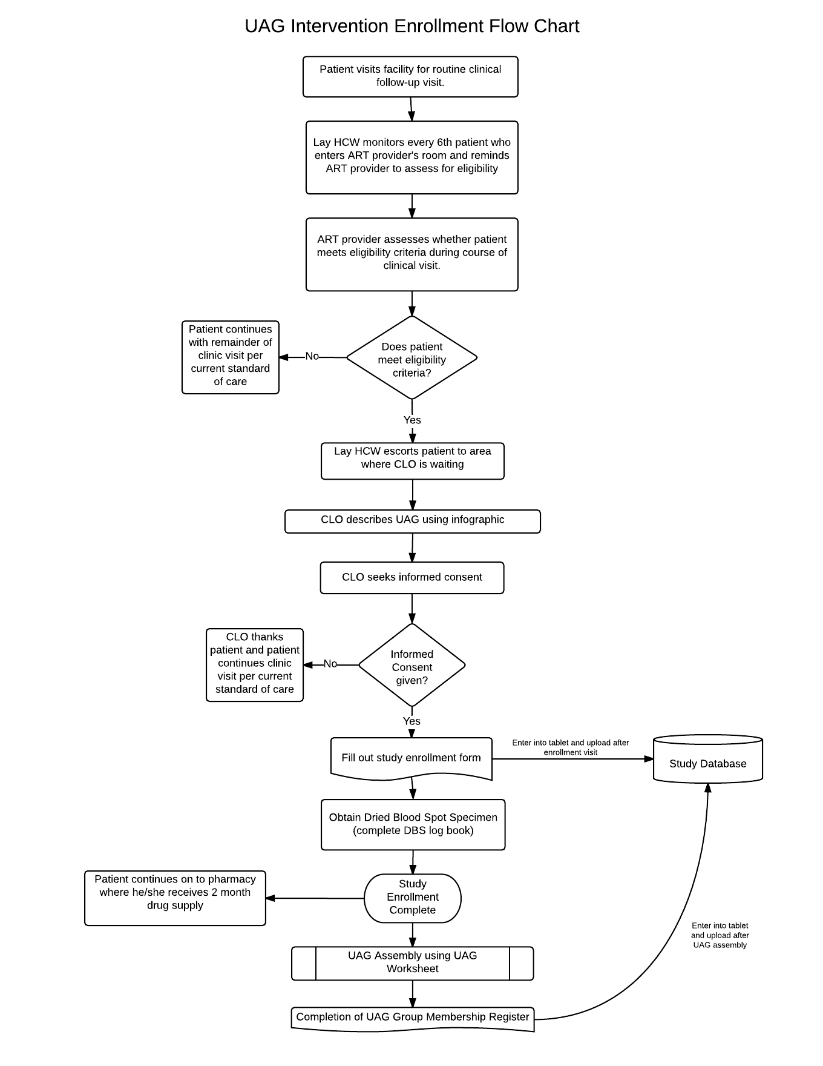
SOP 2.13: Roles and Responsibilities of UAG Personnel

PURPOSE
This standard operating procedure (SOP) describes the key roles and responsibilities for all personnel involved in implementation of the Urban Adherence Groups (UAG) model.

SCOPE
This SOP applies to all personnel involved in the UAG model of health care delivery.

MATERIALS
UAG Enrollment Form
UAG Group Register
UAG Meeting Attendance Register
UAG Appointment Diary
Data Collection Tool

RESPONSIBILITIES

1. Health Care Worker Supervisor (HCW Supervisor) is rresponsible for:
- Conducting enrolment procedures
- UAG Assembly (i.e. UAG group formation)
- Maintaining the group UAG membership register and updating this information in the database as specified in this protocol
- At UAG meetings, completing the UAG attendance register and entering the data into the central database
- Maintaining the UAG appointment diary
- Pulling and storing UAG member files for scheduled clinical visits
- Facilitating clinic visits for UAG members
- Coordinating with clinic tracing staff to ensure patient tracing as outlined in the protocol
- Supporting and supervising the lay HCW in all their duties

2. Lay Health Care Worker (“UAG Supervisor”) is responsible for:
- Assisting the HCW supervisor with enrolment and UAG assembly (i.e. UAG group formation)
- Pulling and storing UAG members’ files for a UAG meeting
- Prior to UAG meetings, pre-filling the UAG attendance register
- At UAG meetings, leading the group adherence discussion
- Alerting the HCW supervisor in the event of a hospitalization or death of a UAG member

3. Pharmacy Technologist is responsible for:
- Dispensing drugs for all UAG members at UAG meetings
- Completing the pharmacy form at the time of drug dispensation for each UAG member
- Communicating as needed to coordinate with the HCW supervisor, lay HCW, and clinic staff about UAG operations

4. All UAG members involved in the UAG are responsible for attending clinic visits and UAG meetings and for abiding by a code of conduct.

5. Data Associate is responsible for:
- Entering completed clinical visit and pharmacy forms into the central database

6. QA/QC Coordinator is responsible for:
- Overseeing all quality control procedures related to this model

PROCEDURES (See Appendix 1: UAG Flowchart)
HCW Supervisor
:
- Procedures during the enrolment period

- Please refer to SOP 2.2 Recruitment and Enrolment of UAG Participants) for the following activities: recruitment, enrolment, and UAG assembly.
- Label each UAG members ART patient file with a sticker on the upper right corner of the cover.
- Work with clinic staff to identify an appropriate separate location for UAG member file storage
- Work with clinic staff to ensure they are aware of the UAG filing system
- The dates of the UAG meetings will have been determined at the beginning of enrolment (see: SOP Participant Recruitment and Enrolment for UAG Model). The dates of clinic visit 1 and clinic visit 2 for each patient will also have been determined during enrolment (see: SOP Participant Recruitment and Enrolment for UAG Intervention). The HCW Supervisor should record the UAG group meeting dates and individual clinic visit dates in the UAG Appointment Diary. For clinical visits, indicate the UAG group number next to the ART ID and patient name.

- Procedures during UAG Meetings

The HCW supervisor is responsible for completing the monthly attendance register during UAG meetings

- To complete the monthly attendance register, the HCW supervisor should answer each of the questions on the form for every patient.
- If a UAG member is present OR if the UAG member designated a buddy to pick up his medications, then “Attended?” should be marked yes (‘Y’).
- If a UAG member designated a buddy to pick up his medications, then “Buddy” should be marked yes (‘Y’). If buddy pick-up, then do NOT answer any additional columns for that patient. The buddy should be informed that the UAG member must attend the next visit. If a UAG member sends a buddy for two UAG meetings in a row, then the buddy is given a 5 day ARV supply and told to inform the UAG member that they should report to the clinic within 5 working days. If the UAG member fails to do so, they will be treated as a missing member (see section below).
- If the UAG member is attending the meeting and says that he/she feels ill, then the specific symptom questions should be asked and each symptom should be recorded as either yes (‘Y’) or no (‘N’). If the UAG member does not feel ill, the specific symptom columns should not be filled out (they should be left blank).
- Assess whether any patients need to be referred to the clinic. A patient should be referred to the clinic if they are ill, are pregnant, or no longer want to be in a UAG. Review the questions on the monthly attendance register to determine if anyone reported being ill or pregnant. Complete the last column of the UAG monthly attendance register titled “Referred to Clinic?” by indicating yes (‘Y’) or no (‘N’).

  - If a UAG member reports being ill, the HCW supervisor should arrange a clinic visit either that day or the next day.
  - If a UAG member is found to be pregnant, the HCW supervisor should refer the patient to the MCH department. The patient can continue in the UAG as a social member but will not continue to receive medications through the UAG. They should be considered a departing UAG member. See the section below on “Procedures for managing the departure of a UAG member” for additional instructions.
  - If a UAG member no longer wants to be in a UAG, the HCW supervisor should arrange a clinic visit. See the section below on “Procedures for managing the departure of a UAG member” for additional instructions.

- After the UAG meeting is complete, the attendance should be reviewed for any missing UAG members or those who have sent a buddy for two meetings in a row. See section on “Managing a missing UAG member” below for additional instructions.
- Data from the attendance register should be entered into the central database within 48 hours of a UAG group meeting.

- Procedures for managing patients who miss a UAG meeting

- If a UAG member misses a UAG meeting and did not designate a buddy to pick up his medications, the pharmacy technologist will collect any unused medications at the UAG meeting and return it to the pharmacy. No attempts to contact the patient by the lay HCW or the HCW supervisor will be conducted. However, if the missing member does not show up to the clinic within 5 working days of the missed meeting, the HCW supervisor will provide the name of the missing member to the clinic tracing staff so that they can be traced according to current clinic standards.
- If a UAG member sends a buddy for two UAG meetings in a row, then the buddy should be given only 5 days of medications and should be instructed to inform the UAG member to report to the clinic within 5 working days. If the UAG member fails to do so, they will be treated as a missing member.
- If a UAG member misses more than one meeting, the UAG member is still potentially eligible to remain in the UAG. However, the decision should be made on a case-by-case basis in conjunction with other clinic staff as needed.

- Procedures for managing up- and down-referrals
  - Work with clinic staff to facilitate a clinic visit for any UAG member needing up-referral to the facility (either temporarily or permanently). A patient may be temporarily up-referred to the clinic because they are ill. A patient may be permanently up-referred if they are pregnant, no longer want to be in a UAG, or it was determined that they must leave a UAG due to misconduct.
  - After the clinic visit, speak with the doctor and other clinic staff to determine whether an up-referred patient will continue receiving medications through the UAG or through the clinic. Notify the lay HCWs of this information so that the lay HCW can prepare for the next UAG group meeting accordingly.
  - If a UAG member requires additional special clinical visits due to illness, the HCW supervisor should communicate with the doctor and other clinic staff after every visit to determine the status of the patient. The HCW supervisor will communicate with the lay HCW regularly to adjust medication pick-up for the next UAG meeting accordingly.
  - For patients who are up-referred because they are pregnant, the HCW supervisor should facilitate a visit to the MCH department. The patient will be considered to be a departing member. See the section below on “Procedures for managing the departure of a UAG member” for additional instructions.
  - For patients who no longer want to be in a UAG or are asked to leave due to misconduct, the HCW supervisor will arrange for a clinic visit at the facility to get the patient re-established in regular care.
  - If a UAG member is being permanently up-referred after a UAG meeting they should be given a 1-month supply of medications until they are linked back into routine care.

- Procedures before and after UAG member’s routine visit to the clinic

Note: UAG members will make a routine clinical visit to the facility to see the doctor/provider every six months

- Review the UAG Appointment Diary on a weekly basis to determine who will be coming to clinic that week.
- Pull a UAG member file from designated storage location the day of or the day prior to a UAG member’s scheduled clinic visit
- After the clinic visit, bring UAG member clinic file to the data clerks’ office for expedited data entry of the clinical form
- Place UAG member file back into designated storage space after the clinical form has been entered into the central database by data associate.
- If the patient misses their appointment and does not come to the clinic within 5 working days of their scheduled clinic visit, the HCW supervisor should communicate with the clinic tracing staff in order to ensure that the patient is traced according to current clinic standards.

- Procedures for managing patients who re-engage in care after a missed UAG meeting or clinic visit

If the missing patient returns to clinic, determine:
  - If the patient feels ill or is due for a clinic visit
  - Wwhether the UAG member wants to remain in a UAG or not
  - The date of the last attended UAG meeting

- If the patient feels ill or is due for a clinic visit, the HCW supervisor should facilitate a visit with the doctor by communicating with clinic staff

- If the patient no longer wants to be in a UAG, arrange for a clinic visit. This patient should be considered a departing UAG member and the group medication pick-up for the group should be adjusted accordingly. See the section below on “Procedures for managing the departure of a UAG member” for additional instructions.

- If the patient feels well, is not due for a clinic visit, wants to remain in a UAG, and the date of the last attended UAG meeting was less than 30 days ago, the HCW supervisor should facilitate medication pick-up at the pharmacy until the next scheduled UAG meeting and arrange for an enhanced adherence counseling visit with the lay HCW.

- If greater than 30 days have elapsed since the last attended UAG meeting, management should be decided on a case-by-case basis.

- Procedures for managing the permanent departure of a UAG member

There are several situations that may result in a member permanently leaving a UAG:
1. No longer wants to be in a UAG (return to care at clinic)
2. Asked to leave UAG because not following UAG rules
3. Transferred to another clinic
4. Transferred to another UAG
5. Pregnant
5. Died
6. Lost to follow-up (patient cannot be located > 30 days after a missed UAG meeting)

If a UAG member departs from the UAG:
- The last column of the group membership register should be completed to record the date that the UAG member departed from the group.
- The UAG Departure form should be completed in the central database

Lay Health Care Worker:

- Reviews UAG code of conduct at first UAG group meeting

- Procedures before and after UAG group meeting
- Pull all 30 UAG members’ ART files from designated storage location one to two days prior to a UAG group meeting
- Uses the UAG group register to pre-fill the following fields on the monthly attendance register: Clinic Name, UAG Group Number, ART ID, and First Name & Surname for each of the UAG members.
- Provide the pre-filled register and the ART files to the pharmacy technologist at least one day prior to anticipated UAG member clinic visit.
- After a UAG group meeting, bring all 30 UAG members’ files to the data clerks’ office for expedited data entry of the pharmacy form
- Place all 30 UAG member files back into designated storage space after the pharmacy form has been entered into the central database by data associate.

3. Procedures during a UAG group meeting
- At a UAG group meeting, the lay HCW will conduct the group adherence discussion at the front of the room while the HCW supervisor will complete the monthly attendance register at the back of the room.

Pharmacy Technologist:
- At least one day prior to a UAG group meeting, the pharmacist receives the 30 files of the UAG group members and the pre-filled attendance register from the lay HCWs.
- Prepares a 3-month supply of ARV medications for all 30 UAG members
- Uses the pre-filled monthly attendance register (given to him/her by the lay HCW) to ensure that medications have been prepared for the appropriate people
- Completes a pharmacy form for each UAG member and dispenses medications for all 30 UAG members at UAG group meeting
- Returns any unused medication (due to missing UAG members) to the main pharmacy stock room.

UAG Member:
- Attendance of 2 clinical visits (roughly 6 months apart)
- Attendance at all scheduled UAG group meetings (every three months).
  - In the event that a UAG member is unable to attend a UAG meeting they should designate a buddy to pick up their medication. A UAG member cannot send a buddy to two meetings in a row.
- Familiarize themselves with and abide by the UAG Code of Conduct which includes being responsible for:
  - Maintaining the confidentiality of any discussions that occur within the UAG meetings as well as other members’ HIV status
  - Actively participating in adherence discussions during group UAG meeting
  - In the event that they are unable to attend a UAG meeting, designating a buddy to pick up their medication

Data Associate:
- Enters clinic and pharmacy forms for all UAG members into the database
- Communicates with HCW supervisors regarding missing data and/or forms

ABBREVIATIONS AND ACRONYMS
SOP Standard Operating Procedure
UAG Urban Adherence Group
HCW Health Care Worker
HCW Supervisor Health Care Worker Supervisor
LTFU Lost to Follow Up

2.13a Appendix: UAG Model Flow Chart
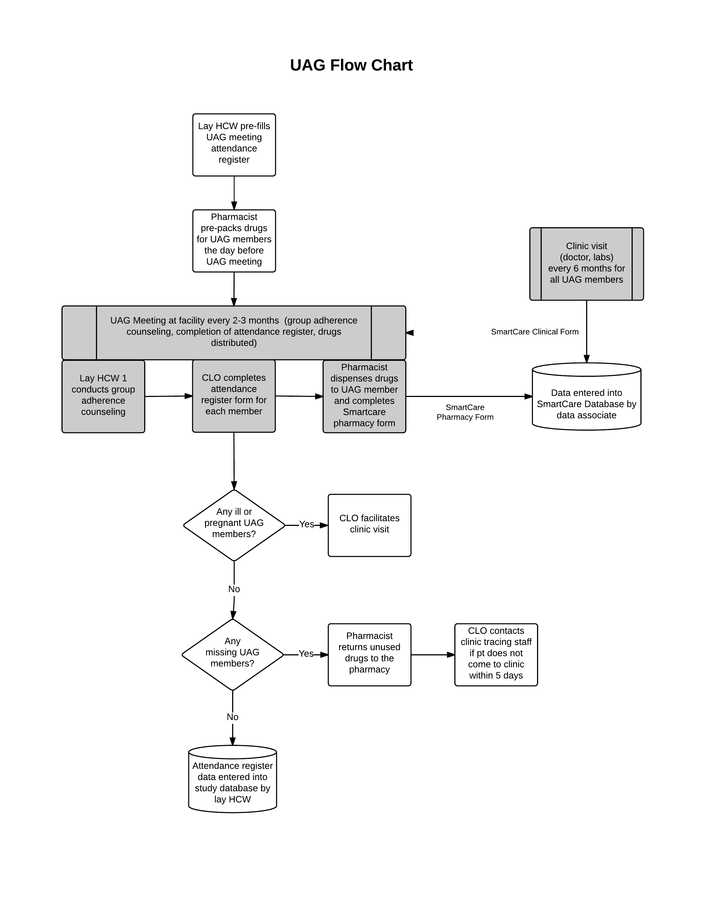

UAG GROUP MEMBERSHIP REGISTER
Clinic Name: |  |  | UAG Group Number: |  |  |  |  | UAG Meeting Day and Time:  (e.g. Monday 16:00) |  |  |  | Date of First UAG Meeting:  (DD/MM/YY) |  | _ _ / _ _ /_ _
ART ID |  | First Name |  | Surname | Sex  (M/F) | DOB  (DD/MM/YY) | Mobile Number 1 | Mobile Number 2 | Date joined UAG  (DD/MM/YY) |  | Scheduled clinic visit 1  (DD/MM/YY) |  | Scheduled clinic visit 2  (DD/MM/YY) |  | Date permanently left UAG¹  (DD/MM/YY)
 |  |  |  |  |  | _ _ / _ _ /_ _ |  |  | _ _ / _ _ /_ _ |  | _ _ / _ _ /_ _ |  | _ _ / _ _ /_ _ |  | _ _ / _ _ /_ _
 |  |  |  |  |  | _ _ / _ _ /_ _ |  |  | _ _ / _ _ /_ _ |  | _ _ / _ _ /_ _ |  | _ _ / _ _ /_ _ |  | _ _ / _ _ /_ _
 |  |  |  |  |  | _ _ / _ _ /_ _ |  |  | _ _ / _ _ /_ _ |  | _ _ / _ _ /_ _ |  | _ _ / _ _ /_ _ |  | _ _ / _ _ /_ _
 |  |  |  |  |  | _ _ / _ _ /_ _ |  |  | _ _ / _ _ /_ _ |  | _ _ / _ _ /_ _ |  | _ _ / _ _ /_ _ |  | _ _ / _ _ /_ _
 |  |  |  |  |  | _ _ / _ _ /_ _ |  |  | _ _ / _ _ /_ _ |  | _ _ / _ _ /_ _ |  | _ _ / _ _ /_ _ |  | _ _ / _ _ /_ _
 |  |  |  |  |  | _ _ / _ _ /_ _ |  |  | _ _ / _ _ /_ _ |  | _ _ / _ _ /_ _ |  | _ _ / _ _ /_ _ |  | _ _ / _ _ /_ _
 |  |  |  |  |  | _ _ / _ _ /_ _ |  |  | _ _ / _ _ /_ _ |  | _ _ / _ _ /_ _ |  | _ _ / _ _ /_ _ |  | _ _ / _ _ /_ _
 |  |  |  |  |  | _ _ / _ _ /_ _ |  |  | _ _ / _ _ /_ _ |  | _ _ / _ _ /_ _ |  | _ _ / _ _ /_ _ |  | _ _ / _ _ /_ _
¹If patient permanently leaves UAG, fill out Departure form in study tablet

UAG MEETING ATTENDANCE REGISTER
Clinic Name: |  |  |  | UAG Group Number: |  |  |  |  |  |  | Date of UAG Meeting  (DD/MM/YY): |  |  | __ __ / __ __ / __ __
 | ART ID |  | First Name |  | Surname |  | Attended (Y/N) | Buddy¹ (Y/N) | Pregnant (Y/N) | Feels ill?  (Y/N) | IF PATIENT FEELS ILL, have they experienced any of the following in the last two weeks? |  |  |  |  |  |  | Referred to clinic (Y/N)
 |  |  |  |  |  |  |  |  |  |  | Fever (Y/N) | Night  sweats (Y/N) | Weight loss (Y/N) |  | Cough (Y/N) | Severe headache  (Y/N) | Other (describe)
1.
2.
3.
4.
5.
6.
7.
8.
9.
¹ If buddy pick-up then STOP and do not fill out any other columns for this patient

UAG GROUP ASSEMBLY WORKSHEET
INSTRUCTIONS: 1. Indicate the meeting times for each group at this clinic in the first column 2. Please mark with an X when a patient is assigned to a particular group
CLINIC NAME
GROUP | NUMBER OF ADDED MEMBERS
GROUP 1  DAY OF THE WEEK:_______________  TIME: ___ ___ : ___ ___  WEEK OF THE MONTH: ______________ | 1 | 2 | 3 | 4 | 5 | 6 | 7 | 8 | 9 | 10 | 11 | 12 | 13 | 14 | 15
 | 16 | 17 | 18 | 19 | 20 | 21 | 22 | 23 | 24 | 25 | 26 | 27 | 28 | 29 | 30
GROUP 2  DAY OF THE WEEK:_______________  TIME: ___ ___ : ___ ___  WEEK OF THE MONTH: ______________ | 1 | 2 | 3 | 4 | 5 | 6 | 7 | 8 | 9 | 10 | 11 | 12 | 13 | 14 | 15
 | 16 | 17 | 18 | 19 | 20 | 21 | 22 | 23 | 24 | 25 | 26 | 27 | 28 | 29 | 30
GROUP 3  DAY OF THE WEEK:_______________  TIME: ___ ___ : ___ ___  WEEK OF THE MONTH: ______________ | 1 | 2 | 3 | 4 | 5 | 6 | 7 | 8 | 9 | 10 | 11 | 12 | 13 | 14 | 15
 | 16 | 17 | 18 | 19 | 20 | 21 | 22 | 23 | 24 | 25 | 26 | 27 | 28 | 29 | 30
GROUP 4  DAY OF THE WEEK:_______________  TIME: ___ ___ : ___ ___  WEEK OF THE MONTH: | 1 | 2 | 3 | 4 | 5 | 6 | 7 | 8 | 9 | 10 | 11 | 12 | 13 | 14 | 15
 | 16 | 17 | 18 | 19 | 20 | 21 | 22 | 23 | 24 | 25 | 26 | 27 | 28 | 29 | 30

Enrollment Form - Intervention
Part 1: General
2. | Which model is patient being enrolled into?  UAG
3. | Date of enrollment (DD/MM/YY): __ __/__ __/__ __
4. | Enrolled by:
5. | Clinic Name:
6. | Patient First Name:
7. | Patient Surname:
8. | ART ID:
9. | Sex (M/F):
10. | Date of Birth (DD/MM/YY): __ __/__ __/__ __
11. | Patient Mobile Number 1:
12. | Patient Mobile Number 2:

Part 2: UAG Model
1. | What type of enrollment is this?  Patient was invited to participate by clinic staff (Go to Question 2)  Patient was invited to participate by someone who is already enrolled in the UAG (Do not answer Question 2. SKIP to Question 3)
2. | a. | If patient was invited by clinic staff, ask the patient: To enter this program, people with HIV need to be on ARVs for at least 6 months AND feel healthy. Do you have any friends in your community that you think meet these requirements AND whom you would like to invite to be in a UAG with you?  Yes No
 |  | ii. | If yes, then ask the patient: Can you tell me how many people you think you might invite?  __________ Number of people
3. | Ask the patient: Can you describe how to get to your house from clinic?  Please provide very detailed directions on how to reach the patient's house from the clinic  DESCRIPTION:  ____________________________________________________________________________________________________________________  ____________________________________________________________________________________________________________________  ____________________________________________________________________________________________________________________  ____________________________________________________________________________________________________________________  MAP:
4 | Based on the patient’s description, what is the name of the neighborhood this patient lives in? _________________________________________________________
5. | Ask the patient: What name do you go by in your neighborhood? _________________________________________
Part 3: UAG Model
1. | Ask the patient: Which of the following adherence groups do you prefer to join?  (Show patient the card of the four options at the clinic)  Please tell me your first choice. If that is not available, what is your second choice?  First Choice Second Choice  Group 1  Group 2  Group 3  Group 4
2. | Ask the patient: In the future, if you could pick when your adherence group meets,
 | a. | Which day of the week would you prefer the most? (pick one)  Monday Tuesday Wednesday Thursday Friday  Saturday Sunday
 | b. | What time of day would you prefer the most? (pick one) Read out all options  Morning (between 8:00 – 12:00)  Early Afternoon (between 12:00 – 14:00)  Late Afternoon (between 14:00 – 17:00)  Evening (between 17:00 – 19:00)
3. | Ask the patient: In the future, there may be adherence groups that are only for women or only for men. Do you think it’s important for men and women to be together or separate, or that it’s not important either way?  I think men and women should be in the same group together  I think men and women should be in separate groups  I don’t have a strong feeling about it either way
4. | Ask the patient: In the future, there may be adherence groups that are only for younger adults (for example, younger than 25) or only for older adults (for example, older than 25). ). Do you think it’s important for younger and older people to be together or separate, or that it’s not important either way?  I think everyone should be in the same group together, regardless of their age  I think younger people and older people should be in separate groups  I don’t have a strong feeling about it either way

